Group Mini Project: Digital Visualization

(CASA0003)

Group Mini Project (Group 9)

Yafei Ye, Yuhong Sang, Bogdan Rugina, Arun Srinivasan

Dr. Duncan A Smith

University College London

Gower St, Bloomsbury, London WC1E 6BT

28-May-2019

# Contributions and Output

|  |  |
| --- | --- |
| Project Output | Output Description |
| Project Output Files | Zip file submitted in Moodle and also available in <https://github.com/disabled-accessible-city> |
| Presentation Slides | Slides used for presentation included as a part of zip file submitted in Moodle. |
| Project Website | <https://disabled-accessible-city.github.io/> |

Table 1 – Project Output Summary

|  |  |  |  |
| --- | --- | --- | --- |
| Task | Contributions | Additional Details | Relevant Chapters in the Report |
| Merging Pages & Layout | Yuhong Sang, Yafei Ye | Pages merging: Yafei Ye, Yuhong Sang  Pages navigation bar and icons designer: Yuhong Sang  Page 1 background and layout designer: Yuhong Sang  Page 1 text contributor: Arun Srinivasan  Page 1 text size change: Yafei Ye  Page 2 layout designer: Yafei Ye, Yuhong Sang  Page 2 text contributor: Yuhong Sang  Page 2 jump function editor: Yafei Ye |  |
| Navigation and Icons design | Yuhong Sang,  Yafei Ye |
| Visualization 1 | Yuhong Sang |  |  |
| Visualization 2 | Arun Srinivasan |  |  |
| Visualization 3 | Yafei Ye |  |  |
| Visualization 4 | Bogdan Rugina |  |  |
| Presentation | All Members |  |  |
| Report | All Members |  |  |

Table 2 –Summary of the Individual Contributions to the Project

# Introduction

One billion of the world’s population have a disability, with an estimated 80% of people with disabilities living in developing countries. With the current state of disability being this high, UN have suggested that by 2050, it is expected that about 6.25 billion people, 15 percent of the population will be persons with disabilities living in urban cities. Even though a lot of developed urban cities are putting together plans and facilities to aid the disabled, it is truly “invisible” whether the urban landscape are fully capable and inclusive to handle this surge which will allow the disabled to live a life no different than able-bodied people.

In large urban cities, transportation plays a key role in helping its people from getting from point A to point B. A recent study shows that a person with disability must travel 49% longer than an able-bodied person in London which is considered to have one of the best transportation systems in the world. – We magnify into disabled transportation accessibility across the UK to see whether the accessibility of the train travel and the distribution of the disabled population are correlated. We also try to investigate the status of the density and proportion of the disabled people to the accessible train stations. We also try to see if there exists a gap between accessibility and disability by exploring a certain city or region.

A recent survey conducted among 500 employers by YouGov shows one in four UK employers would not hire someone with a disability and more than half of them agreed that it is easier to hire an able-bodied person over a disabled person. – We go into the disability employment statistics published by the Office for National Statistics and tries to visualize the gap in employment and unemployment rates between the disabled and able-bodied. We go over 13 years of data to see how the employment of disabled has changed in London. We also try to provide a level of interactivity in the visualization to the user that allows them to navigate across different boroughs across years.

Last year, the Minister for Disabled People in UK said that the food & drink industry could be missing out on the ‘Purple Pound’ which is worth an estimated £249bn a year. We try to visualize the current wheelchair accessible businesses in London according to Yelp API. We also try to allow users to search for options and view detailed information about the corresponding businesses. We also try to analyse the distribution of businesses in each borough of London and also analyse the percentage that wheelchair accessible businesses take up in all business in London.

London has recently set aside £300m to improve its inclusiveness of the disabled and has vowed to implement new measures by 2030 – We investigate Manchester City’s journey into transforming the city and the policies which could be used across UK. We try to visualize the future interventions such as projects and plans that tackle the accessibility aspect within the Manchester Transport Strategy for 2040. We try to investigate if these projects support long-term, sustainable economic growth and access to opportunity for all and if it promises an inclusive transport accessibility for the disabled. We also try to find within each policy and intervention any objective focusing the urban access issue.

# Gap between Accessibility and Disability in Great Britain

* 1. Design & Approach

According to Department for Transport (2017), 9% of adults have difficulty on mobility. Disabled people over the age of 16 have 38% less trips than those with no disability. Among people over the age of 70, this ratio is 50%. The accessibility to disabled people of the railway public transport (% fully accessible vehicles) increased by 5 percentage points in 2016-2017, at 75%. As specified in the Equality Act 2010, ‘all station operators to take reasonable steps to ensure that they do not discriminate against disabled people’ (Department for Transport, 2015). Currently, the Department for Transport and Disabled Persons Transport Advisory Committee is working to maximize the accessibility of trains by 2020.

There are many facilities that can improve the accessibility of the station (Network Rail, 2019), such as:

1. lifts that are automatic and give an audible tone when the doors open and close
2. staircases and platform edges that have tactile warning surfaces
3. new ramps and footbridges with lowered handrails
4. open entrances and new ticket gates
5. accessible waiting rooms and toilets

As far as the status quo is concerned, there is still a gap in the complete accessibility of train transportation. Visualization can better assist with the analysis. This visualization aims to analyse whether the construction of the accessible facilities in train stations match the distribution of the disabled population. In this section, accessibility represents the percentage of accessible rail stations in all stations in the local authority. A special case is when the number of rail stations of the local authority is 0, the proportion is 0. Disability represents the disabled population density and proportion in local authority.

There are six raw data files for the visualization. These six data files include four table files (csv and xls) and two shapefiles:

1. Great Britain Local Authority Districts Boundaries shapefile (Office for National Statistics, 2017)
2. England and Wales Disability Data xls file shapefile (Office for National Statistics, 2012)
3. Scotland Disability Data csv file (Scotland’s Census, 2013)
4. Great Britain Rail Stations Location csv file (Doogal, 2019)
5. Great Britain Rail Station Accessibility Data csv file (Paulley, 2018)
6. UK Rail Lines shapefile (Diva-GIS, 2019)

The first five pieces of data have been processed and integrated before being used for the final html page visualization:

1. England and Wales, and Scotland's disabled population data are cleaned up via Excel and ArcMap and integrated with the local authority's polygon layer.
2. Use ArcMap to calculate the area of each local authority polygon.
3. The table with the geographic information of the train station is converted into a point layer by the display latitude and longitude coordinates in ArcMap and integrated with the station accessibility data.
4. Use ArcMap to calculate the number of all station points and accessible station points in each local authority polygon.
5. Use ArcMap to calculate the corresponding accessible station population, disabled population density and proportion.
6. The integrated shapefiles are uploaded to the Mapbox.

First, the green layer represents the proportion of accessible stations in each local authority. Different green shades correspond to different percentages. The darker the green area, the lower the percentage. When users use the mouse hover on different local authorities, in the information bar in the lower left corner, users can get the number of accessible stations and total stations, as well as the disabled population of this local authority.

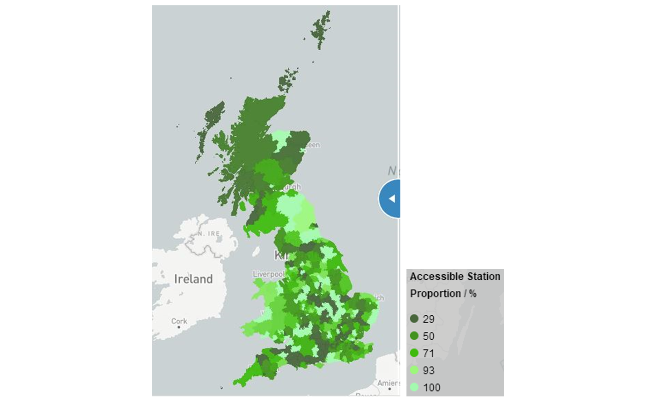

Figure 1 - Accessible Station Proportion

Second, when users drag the blue slider, users can see more layers and compare them with accessibility. The blue and grey dot layers show the distribution of accessible and inaccessible stations. The grey line layer shows the rail lines. In the top right corner of the page, users can choose to show and hide them separately (Mapbox, 2019a). Similarly, when the mouse hover over different stations, users can also get information about the accessible facilities of this station. In addition, after dragging the screen, users can filter and find stations in the search box that appears on the left (Mapbox, 2019b).

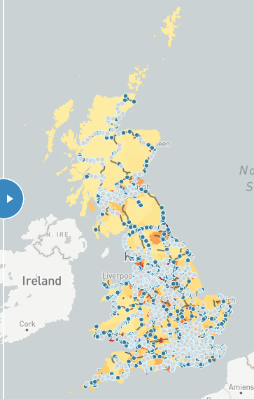

Figure 2 - Rail Stations and Lines

Then, it's the core function of this page: comparing the status of accessibility and disability (Mapbox, 2019c). Users can choose to switch between density (disabled population / area of local authority) and proportion (disabled population / total population of local authority) layer. Dark areas have a higher disabled population density and proportion. The zoom feature of several major cities is available at the top left.

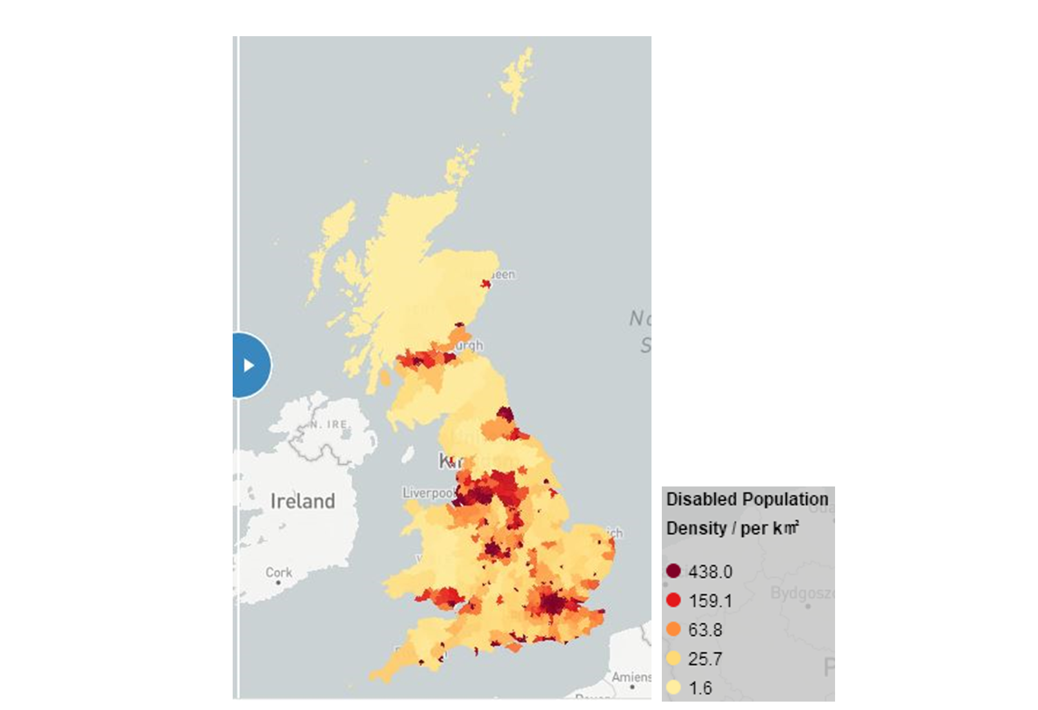

Figure 3 - Disabled Population Density

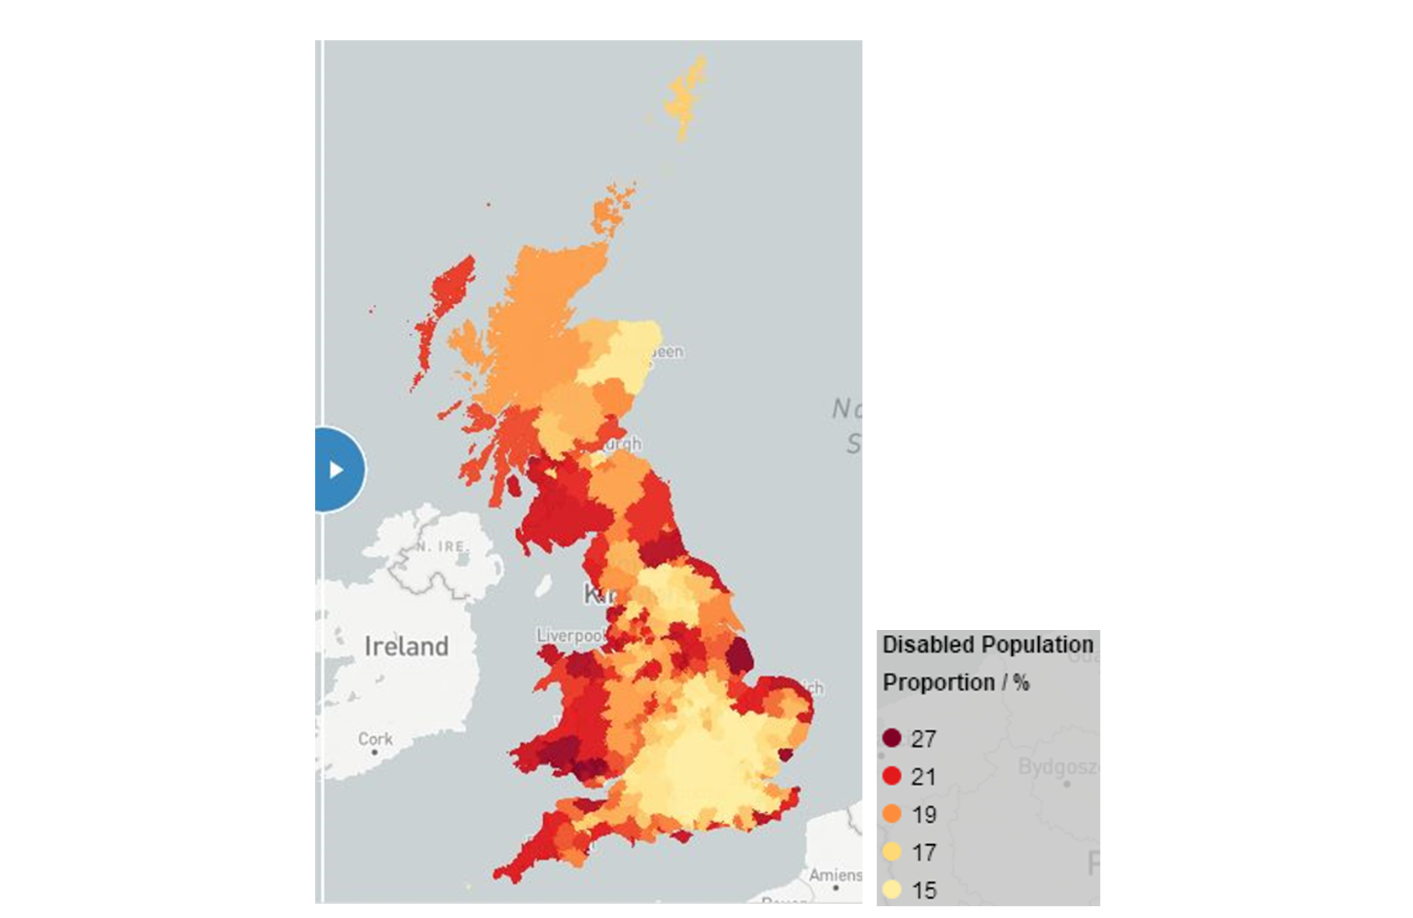

Figure 4 - Disabled Population Proportion

* 1. Results

By observing several maps in the visualization, a few simple results can be obtained. Based on the choropleth map of the disabled population density, it is easy to find the major economic city has greater density. This may be since the total population of these regions is even larger. Looking at the disabled population proportion, the local authorities with larger proportion are concentrated in the coastal areas. Perhaps because the coastal areas are more liveable. Take accessible station proportion as a comparison, it can quickly understand that the disabled population proportion is more in line with the accessible station proportion, which directly reflects the correlation with demand. The difference is that the disabled population density is less consistent with the accessible station proportion. In order to better understand the reasons, it need to do more specific analysis.

Here will choose two specific regions to explore. The first is Greater London. Its disabled population density is completely different from the proportion. There are more stations distributed in London's local authorities. Although the proportion of accessible stations is not large, the number of accessible stations is higher. Therefore, disabled people can find more alternative stations within a short distance.

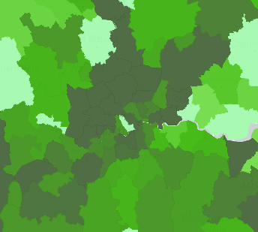

Figure 5 - Accessible Station Proportion (London)

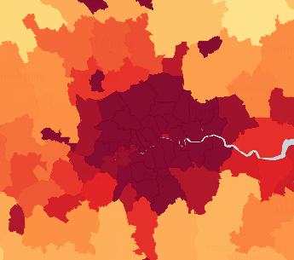

Figure 6 - Disabled Population Density (London)

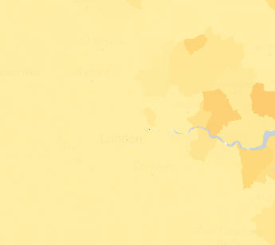

Figure 7 - Disabled Population Proportion (London)

The second is Liverpool and Knowsley. Their disabled population density and proportion are both relatively high. These two adjacent and similarly sized cities are a good verification of many of the results that have previously obtained. They are in major economic and coastal areas. On the one hand, Liverpool has a higher disabled population density and a lower proportion than Knowsley. On the other hand, Liverpool has more than twice as many accessible stations as Knowsley, and with a lower accessible station proportion.

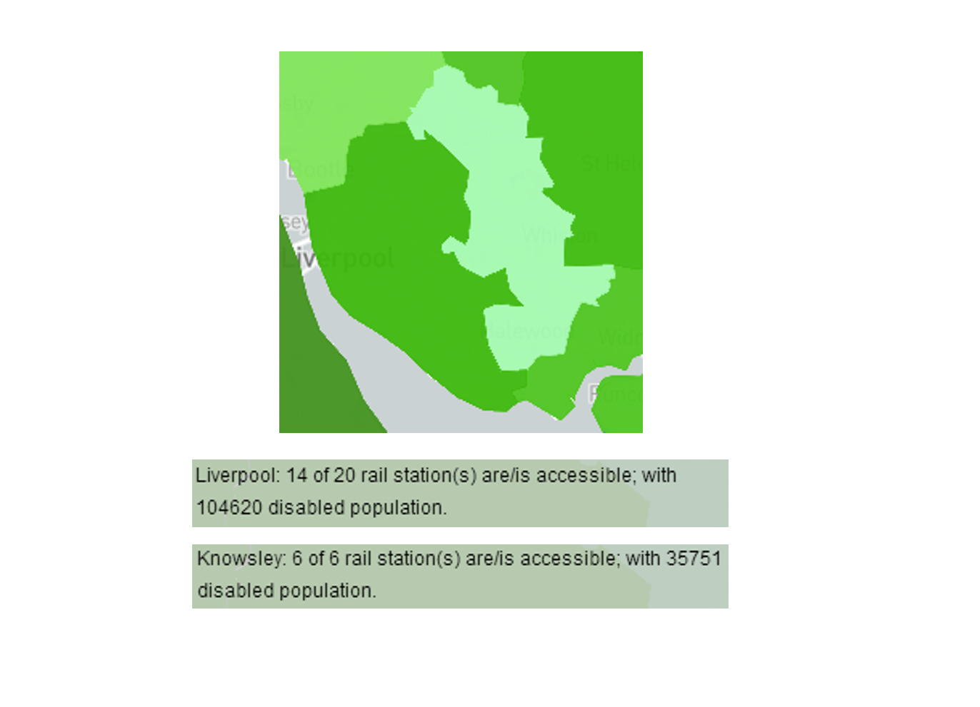

Figure 8 - Accessible Station (Liverpool and Knowsley)

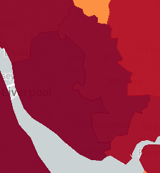

Figure 9 - Disabled Population Density (Liverpool and Knowsley)

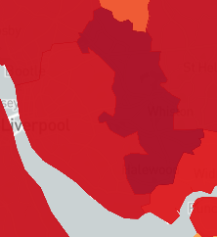

Figure 10 - Disabled Population Proportion (Liverpool and Knowsley)

As a small conclusion, disabled population density and proportion have significant differences in different local authorities. Comparing them with accessibility proportion will get different results. Accessibility in Great Britain is somewhat compatible with the disability status. However, different improvements are still needed. In the local authority with a higher disabled population density, although the number and density of accessible stations are higher, the proportion is lower. In the local authority with a higher disabled population proportion, although the proportion of accessible stations is very high (close to 100%), due to distance factors, disabled people may need to overcome more difficulties to reach the stations. This is not a part of this visualization; however, it is an area worthy of follow-up attention.

# Disabled Employment Statistics

* 1. Design & Approach

The data obtained from the Office for National Statistics (data.london.gov.uk, 2019) and is a static time-series dataset. The dataset comprises of data that is divided across the different boroughs of London. Since the dataset has a lot of features, it was cleaned to include only the % of disabled people among the economically active (people who don’t have a job and are actively looking for one), % of the employed and unemployed disabled and able-bodied people. Even though numerical data was present, a decision was made to go with the % statistic as it was more easily interpretable. Data for the City of London Borough missing through the dataset, so the visualization excludes that borough. Data was missing for the year 2013 due to changes in the health questions on the Annual Population Survey. This was overcome by taking a mean of the years 2012 and 2014. Disabled Unemployment data was missing for a few years in certain boroughs. This was overcome by calculating the mean of the previous and following years.

The Statistical GIS Boundary Files (data.london.gov.uk, 2019) for London published by the Greater London Authority. These files were loaded as tilesets into Mapbox to plot the boundary of the boroughs on the map of London. Each of these boroughs are identified by an area code which can be used to map them with the dataset.

To provide a level of interactivity to the visualization, we have introduced 2 input controls that allow the user to control the years between 2004 and 2017 and the disabled employment/unemployment rates. This was achieved by providing 2 radio controls to toggle between the employment and unemployment rates using the bootstrap (Otto, 2019) open source toolkit for developing with JS. A lightweight JS library called noUiSlider (Gersen, 2019) was used to setup a slider to allow the users to navigate between years in the dataset. Based on the selected radio control and the year selected on the slider, the boroughs on the map get coloured based on their data in the dataset.

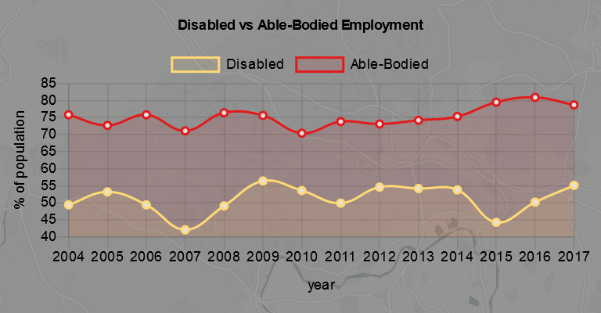

Figure 11 – Automatically Rendered Chart based on-hover action

There is also an on-hover action setup which renders a chart and statistics for a borough based on which borough the mouse is pointed over. A prebuilt JS library called chart.js (Chartjs.org, 2019) was used to render charts that show the journey of a borough’s disabled employment through the years against the non-disabled employment rate.

The statistics section displays a standard text with variables changing based on the on-hover action. The text is having variable statistics which varies based on the borough hovered on.

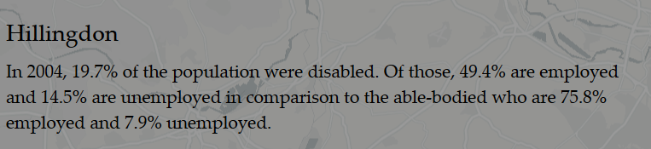

Figure 12 – Automatically rendered statistical data based on-hover action

The script is designed to fetch the borough code from the tileset and matching it with the dataset. This is then fed to the chart.js and the dynamic statistic text to display.

The final visualization design came out as shown in Figure 13.

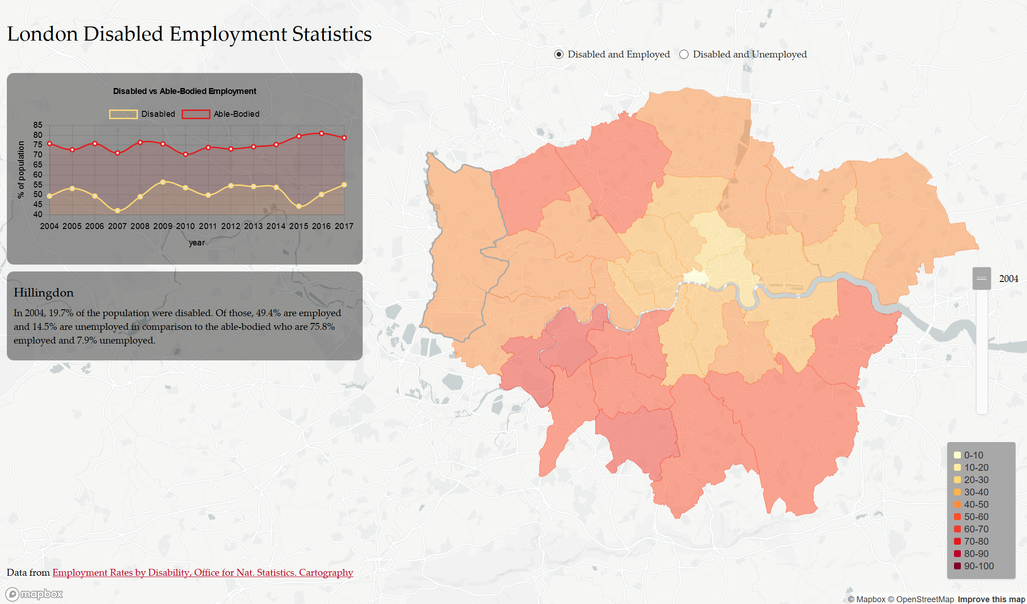

Figure 13 London Disabled Employment Statistics Design

# Results

Reviewing the final visualization, it could be noted that that the employment rate across London

# Wheelchair Accessible Businesses in London

* 1. Design & Approach

This section focuses on wheelchair accessible businesses, which can reflect the living convenience for disabled people who travelling around by wheelchair. For nearly 1 in 5 people are disabled in the UK, wheelchair accessibility is not only important for disabled people, but also beneficial for the owner of a business so that the target market can be enlarged a lot (Euan's Guide, 2019). To visualize and analyse the current situation about wheelchair accessible businesses, data from Yelp – a famous review forum is being used. London, which has the most businesses in the UK as the capital, has been chosen as the case.

* + 1. Objectives

The points listed below are the main objectives for this part:

1. Draw a map of the current wheelchair accessible businesses in London so that the distribution can be seen straightforwardly;
2. Create a search function that people can find their positions and read detailed information about businesses around easily;
3. Investigate the distribution of wheelchair accessible businesses in each borough of London to analyse the spatial unfairness;
4. Calculate the percentage that wheelchair accessible businesses take up in all businesses in London to show the emphasis degree of business wheelchair accessibility.
   * 1. Methods

HTML is utilized to do the visualization based on Yelp API, Mapbox GL JS and CanvasJS.

Data acquisition and processing

1. Python: python is used to retrieve Yelp (2019a) business search responses by adjusting Sigma Coding’s (2018) tutorial code. By setting ‘limit’ and ‘offset’ values learnt from london-rhythms’ (2018) Github code, this endpoint can return up to 1000 businesses. For the quantity of any category of wheelchair accessible business in London is less than 1000, complete responses can be returned. Every category of business response is transferred into csv after data cleaning and reconstruction;
2. Excel: according to Yelp (2019b) Category List, there are 16 categories of wheelchair accessible businesses available in London. To reduce the number of categories, some similar categories are combined together in Excel. Finally, the csv files of 8 main categories are merged: Restaurants, Food, Shopping, Travel (Event Planning & Event Services + Hotel & Travel), Leisure (Sports & Leisure + Arts & Entertainment + Education), Night Life, Beauty & Health (Beauty & Spas + Health & Medical), Local Services (Home Services + Local Services + Pets + Professional Services + Government & Public Services);
3. ArcGIS: the csv files obtained in step 2 are imported to ArcMap and joined with London Boroughs shapefile (London Datastore, 2018) to calculate the quantity of businesses in each borough (figure 1). Then, a new borough shapefile with business attributes is exported;

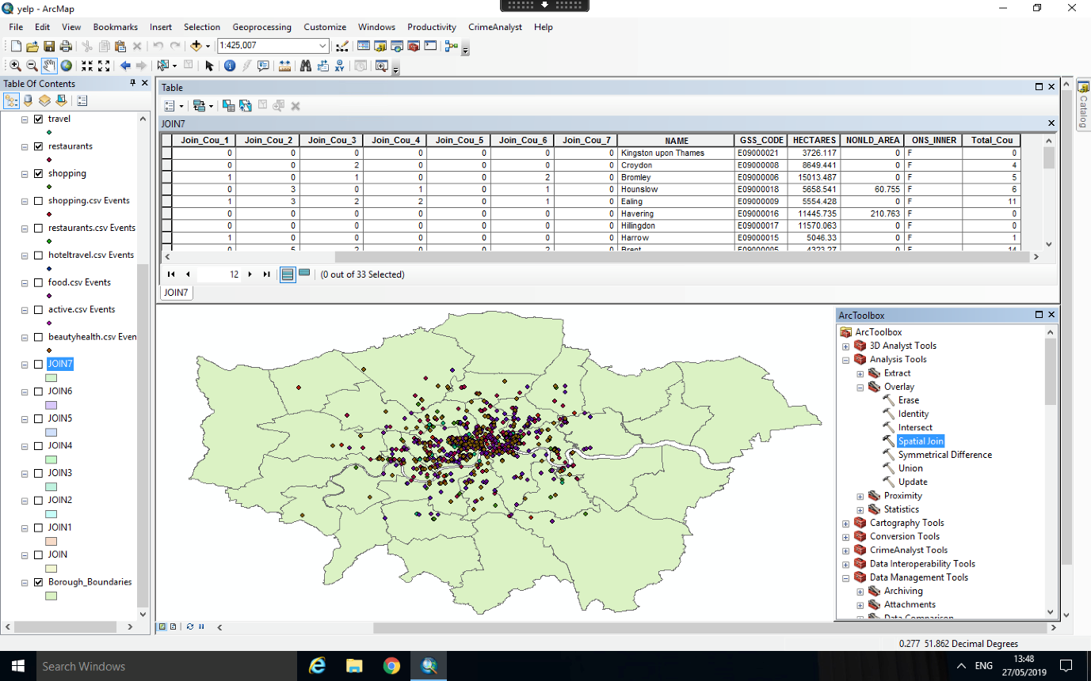

Figure 14 - Join Business Points with London Borough Boundary Polygons in ArcMap

1. Mapbox Tilesets: all csv files and the shapefile achieved above are uploaded into Mapbox as tilesets;

Interactive Website Construction:

1. Tilesets in step 4 are added as layers in html script and buttons which can show and hide these layers are generated by modifying code in Mapbox (2019b) GL JS examples;
2. The hover highlight effect for boroughs are built by altering the code teachers showed in week 3 practical;
3. The search function is produced according to Mapbox (2019a) Geocoder;
4. The popup for business points and boroughs is created based on solutions in StackExchange (2018);
5. Charts are appended by changing code offered by canvasJS (2019).
   1. Results

As the final website visualization shows (figure 2), from the map in the middle and the chart in the left, obviously, most wheelchair accessible businesses are in the inner London. Especially in Westminster, the quantity of every type of business is several times than any other boroughs. It indicates that it’s unfair for disabled people who live in outer London for they must travel a long time to arrive in the businesses which are marked as ‘wheelchair accessible’ in Yelp.

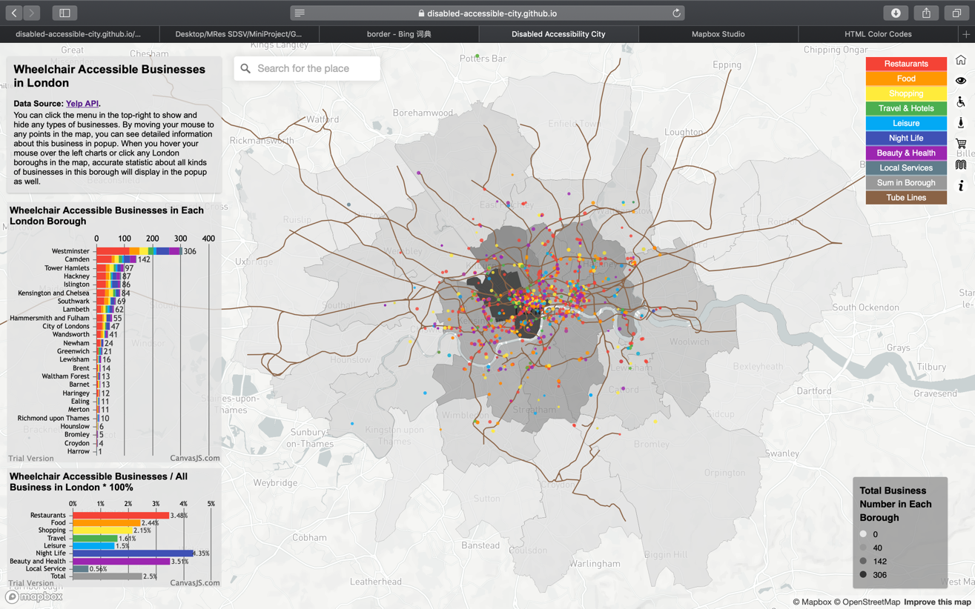

Figure 15 - Final Website Visualization

By clicking the buttons in the top-right, we can show or hide the layer of every category of business. As we close all layers at first and display them one by one, we can see that restaurants are clustering in the West End and the East End of London. After open food layer, which includes cafes, groceries and so on, we can find that the location of them is very similar to restaurants. For shopping stores, such as shopping centres and bookstores, again, they love to be the neighbours with restaurants. However, for hotels and other travel-related facilities, they are more likely to distribute in the boundary of high-density area of restaurants and shops. It makes sense because they want to be convenient to access restaurants and shops while they wish the environment is not so noisy (figure 3).

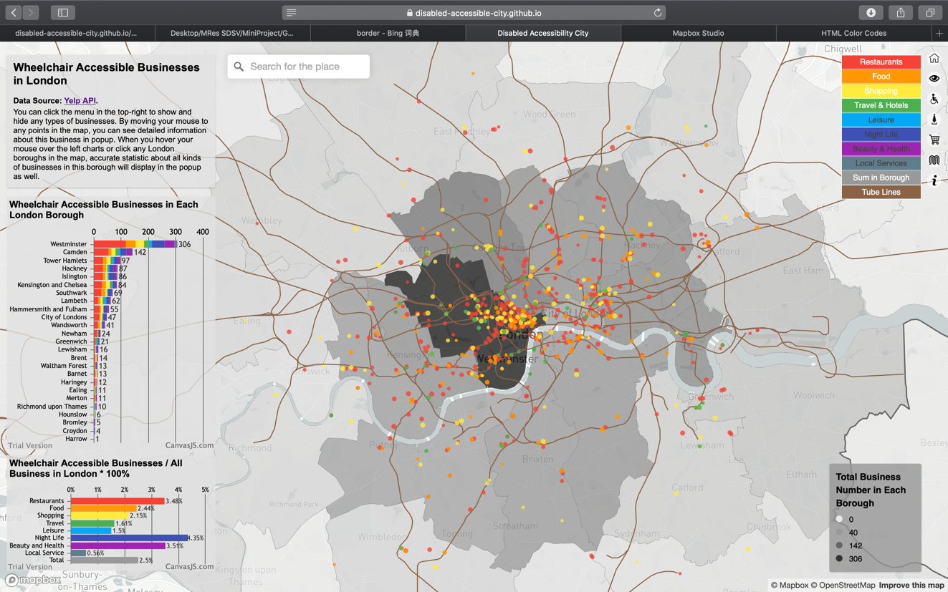

Figure 16 - Distribution of Restaurant, Food, Shopping and Travel Businesses

In addition, when we close all other layers but only open travel layer (figure 4), we can find that almost every wheelchair accessible hotel is very close to tube lines so that more transportation convenience can be created for disabled people.

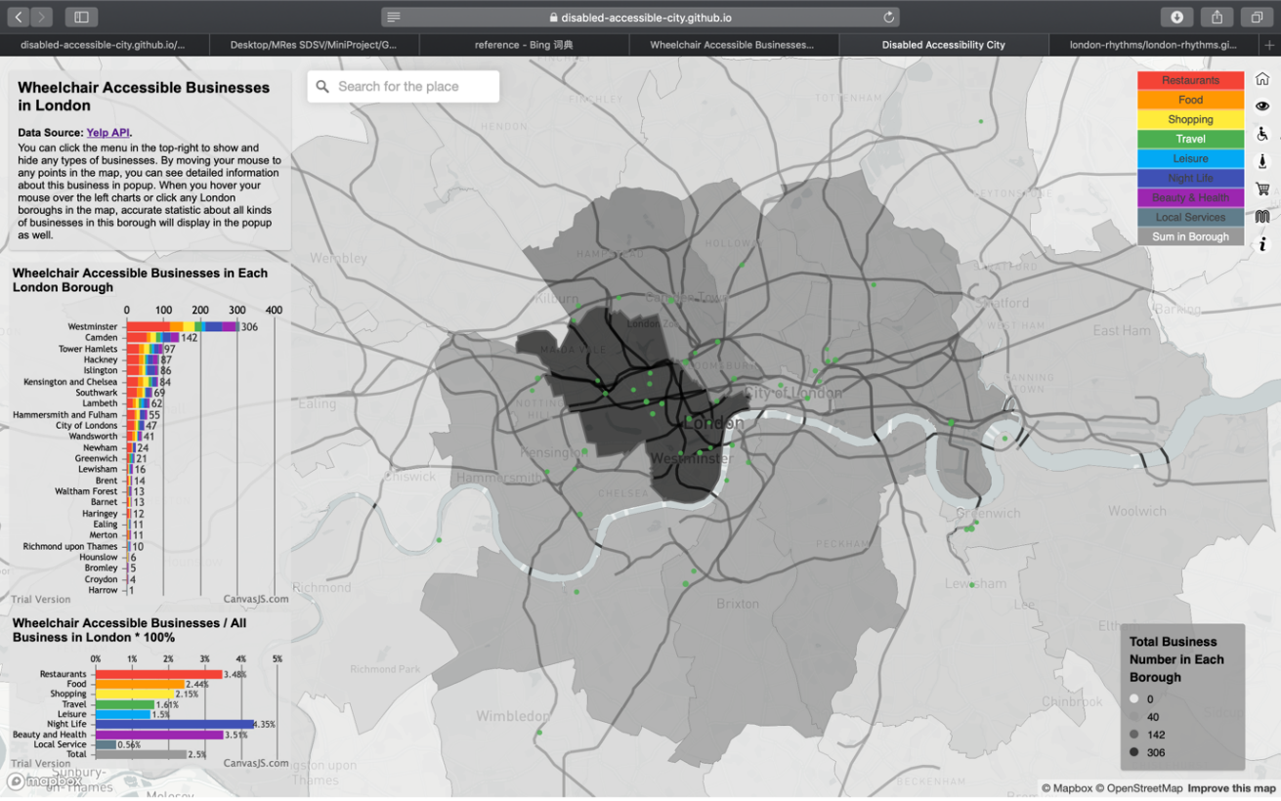

Figure 17 - Distribution of Travel Businesses

For leisure facilities (figure 5), such as museums, theatres, gyms, they seem scatter more randomly in London.

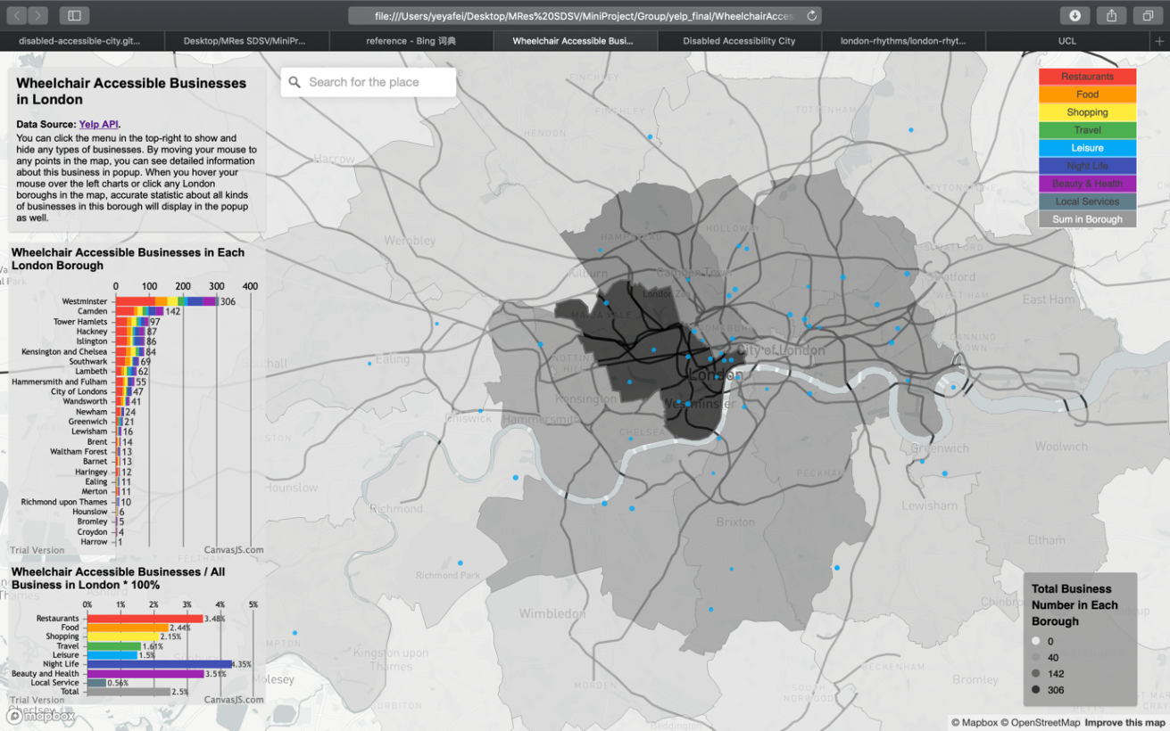

Figure 18 - Distribution of Leisure Businesses

For night life facilities, such as pubs and bars, and beauty and health stores, such as barbers, skin care and massage, if we can remember the distribution of restaurants, they are quite similar (figure 6).

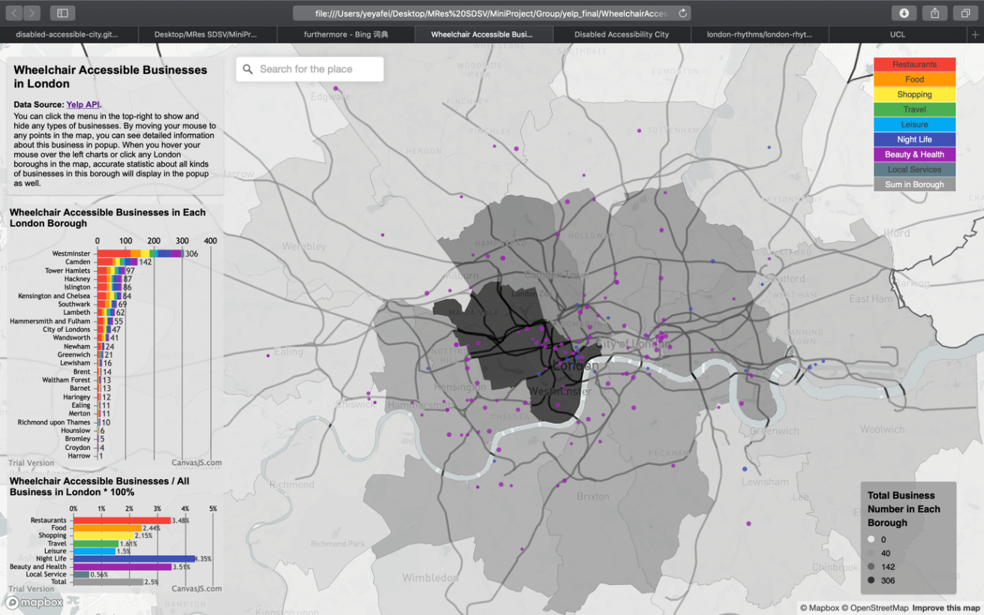

Figure 19 - Distribution of Night Life and Health & Beauty Businesses

For local services, such as computer, phone, bike repair stores, they gather in oxford street and locate randomly in other area (figure 7). Based on these regulations we investigated, disabled people can seek out the place which fits their needs more quickly.

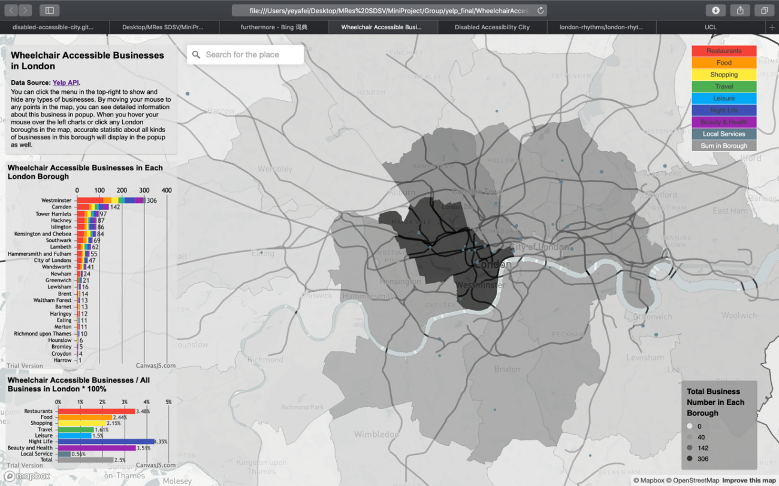

Figure 20 - Distribution of Local Service Businesses

There is a search bar in the middle top as well, people can search for their locations and the map will zoom in to this place. Taking UCL as an example (figure 8), we type UCL and search, then the map will zoom in to UCL. If we want to seek for restaurants which is accessible for wheelchair, we just move the mouse to the red points around to see the popup which displays the name, picture, category, price level and rating scores of every business. Furthermore, the point radius has been set equal to rating score: higher the rating, bigger the points, so that we can find the most satisfied place rapidly.

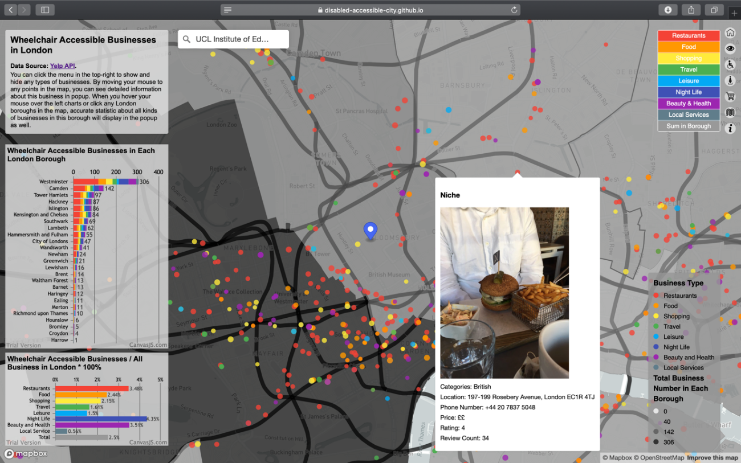

Figure 21 - Search Function and Business Popup

By clicking each borough in the map (figure 9) or the charts (figure 10), we can see a popup with accurate numbers of businesses in this borough as well. As a result, we can learn the current situation of living convenience for disabled people in each borough of London more deeply.

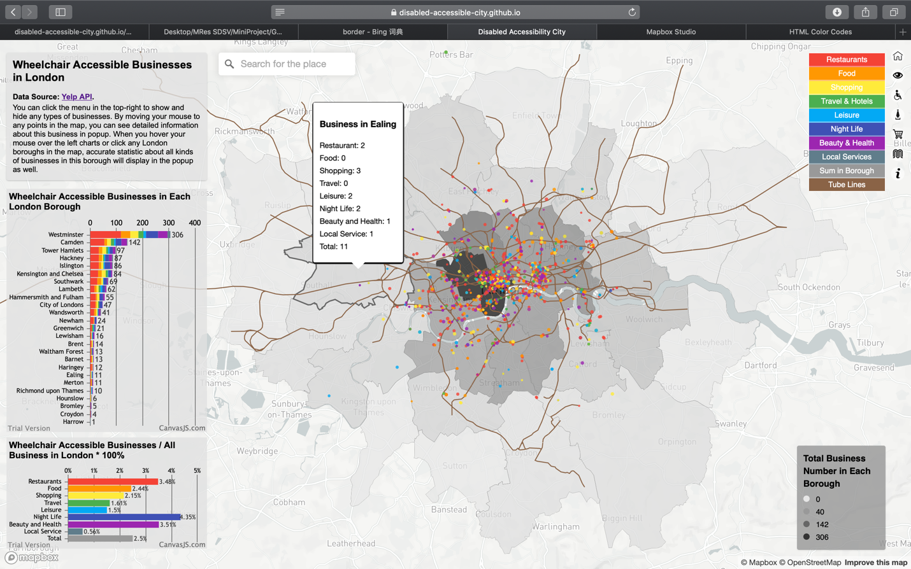

Figure 22 - Borough Business Popup

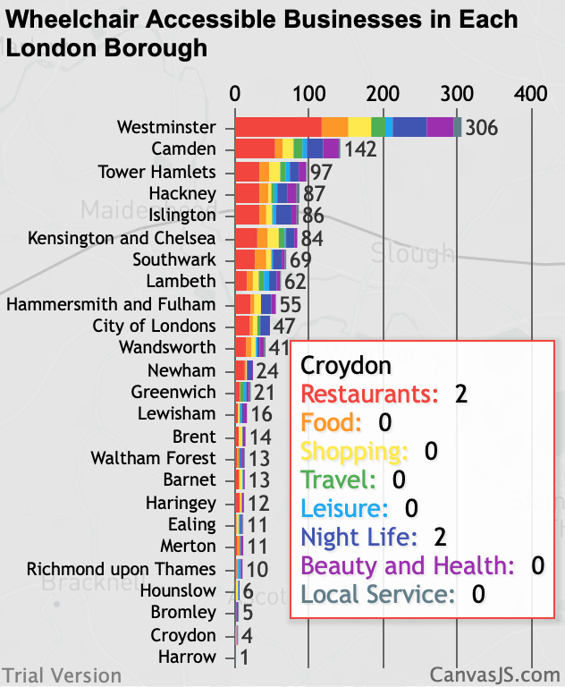

Figure 23 - Stacked Histogram on Wheelchair Accessible Businesses in Each London Borough

The chart about the percentage of wheelchair accessible businesses in total quantities of each type of business in the bottom-left (figure 11) demonstrates that businesses in London generally pay little attention in disabled people. All kinds of businesses take up less than 5%, particularly for local service, which only takes up 0.56%.

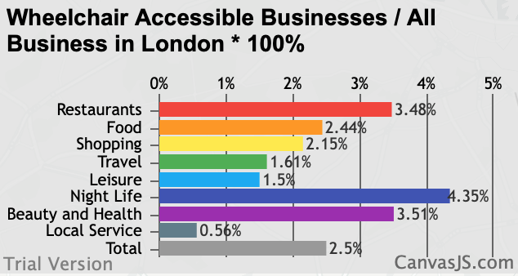

Figure 24 - Histogram on Wheelchair Accessible Businesses / All Business in London

In conclusion, the current wheelchair accessible businesses situation in London is a little terrible. However, it may cause by the bias of data source.

# Accessibility in Manchester – Transport Strategy 2040

* 1. Design & Approach

The main objective of this section is to visualize the future interventions such as projects and plans that tackle the accessibility aspect within the Manchester Transport Strategy for 2040. This was made by finding within each policy and intervention any objective focusing the urban access issue.

Accessibility in relation to public transportation has a very wide literature, urban transport systems around the world have faced the challenges to bring everyone the possibility to move, both under the social lenses (Bocarejo and Oviedo, 2012), (Preston and Raje’ 2007) and disabled people accessibility (Hine, 2016). The urban environment in most of the developed countries faces also a strong increase in ageing population which demand for accessible ramps, safe pedestrian facilities, all urging an incorporation of accessibility plans into the strategic agenda (Sze and Christensen, 2017).

Recently, the Great Britain Department for Transport (2018) has released the Inclusive Transport Strategy which aims is to “improve accessibility across all types of travel for those with both visible and visible disabilities”. The ambition of this national initiative is to achieve a fully accessible transport system by 2030.

Under this light is was very interesting to investigate the Greater Manchester direction when is about transport accessibility (Transport for Greater Manchester, 2019). The strategy, specially focused to improve connectivity at regional and local level, sizes its 2040 goal to support long-term, sustainable economic growth and access to opportunity for all. The document states two sub-sections when is about accessibility, one regards the social aspect of “Access to Employment, Service and Leisure” and the other a more infrastructural value of ‘Improving Access’. The visualization in this case will be referred to this last sub-section, which tends to answer the needs of people commuting day by day, especially with public transport modes through the provision of more effective interchanges options from cycle parking to bus links and even car parking. The Strategy last section “Policies and Interventions” identifies a series of projects to be carried out by the 2040 term, Table 3 . shows the interventions which contain access or accessibility as objectives.

|  |  |  |  |  |  |  |
| --- | --- | --- | --- | --- | --- | --- |
|  | Intervention | Rationale | Cost (Low/ | 2040 Ref. | Completed | Type |
| 1 | Salford Bolton Network improvements, including bus priority at junctions | To create shorter, more reliable journey times for all road users and deliver better access to employment and local facilities for bus passengers. | M | W.02.01 | 2020 | Public Transport: Bus |
| 2 | Mobility Hubs/Park & Ride upgrades along the Bury Line (Radcliffe and Whitefield) | To provide better access to public transport through Mobility Hub/Park & Ride facilities. This in turn will encourage a modal shift in Greater Manchester. | L | N.01.07 | 2040 | Public Transport: Metrolink and Bus Rapid Transit |
| 3 | Additional Metrolink vehicles (27 new trams) and associated infrastructure - enabling the use of more double unit vehicles between Bury and Altrincham, and Shaw and East Didsbury. | To increase Metrolink capacity into and through the Regional Centre, in order to facilitate continuing economic growth and access to services and encourage mode shift. | M | RC.03.01 | 2020 | Public Transport: Metrolink and Bus Rapid Transit |
| 4 | Station accessibility improvements at Mills Hill | To maximize existing rail assets to provide better facilities, particularly for passengers with limited mobility. | L | N.01.02 | 2040 | Rail |
| 5 | Rail Station Accessibility Programme to deliver accessibility improvements at rail stations | To maximize existing rail assets to provide better facilities, improve transport integration and deliver community benefits. | M | N.01.01 | 2040 | Rail |
| 6 | Carrington Relief Road | To support growth in the Carrington area by improving accessibility to new developments. | M | W.09.13 | 2020 | Streets for All: Local Highways |
| 7 | City Centre Salford infrastructure improvement: New Bailey | To support the redevelopment and growth of Central Salford by delivering public realm and environmental improvements, alongside enhancements to public transport access and improvements to bus reliability. | L | RC.10.04 | 2020 | Streets for All: Walking and Cycling |
| 8 | Stockport Town Centre Access Plan | To tackle congestion in and around Stockport town center and remove barriers to movement for all modes. | M | W.04.01 | 2020 | Integration: Town Centers & Interchanges |
| 9 | Ashton Interchange redevelopment | To increase the accessibility of Metrolink, bus and rail from nearby destinations, and increase the attractiveness of the Interchange as the focal point for intra-urban growth in Ashton town center. | M | W.03.01 | 2020 | Integration: Town Centers & Interchanges |
| 10 | Stockport Interchange redevelopment | To increase the accessibility of bus and rail from nearby destinations and increase the attractiveness of the Interchange as the focal point for intraurban growth in Stockport town center. | M | W.03.02 | 2020 | Integration: Town Centers & Interchanges |

Table 3 - Interventions and Projects related to the accessibility objectives

The next step consisted in filtering all the projects that could have a better visualization. For this reason, Intervention 1 “Salford Bolton Network improvements”, Intervention 2 “Mobility Hubs/Park & Ride upgrades” and Intervention 8 “Stockport Town Centre Access Plan” were excluded as they have a more visionary value that would make their design complicated.

In order to import into Mapbox all the interventions as “tilesets” and code the interactive features, an intermediate passage was needed to create the shapefiles. Since the Manchester Council has not released any of the vector file related to these projects, the only feasible way was to create them on the ArcMap software, helped also by OpenStreetMap database covering the Manchester area.

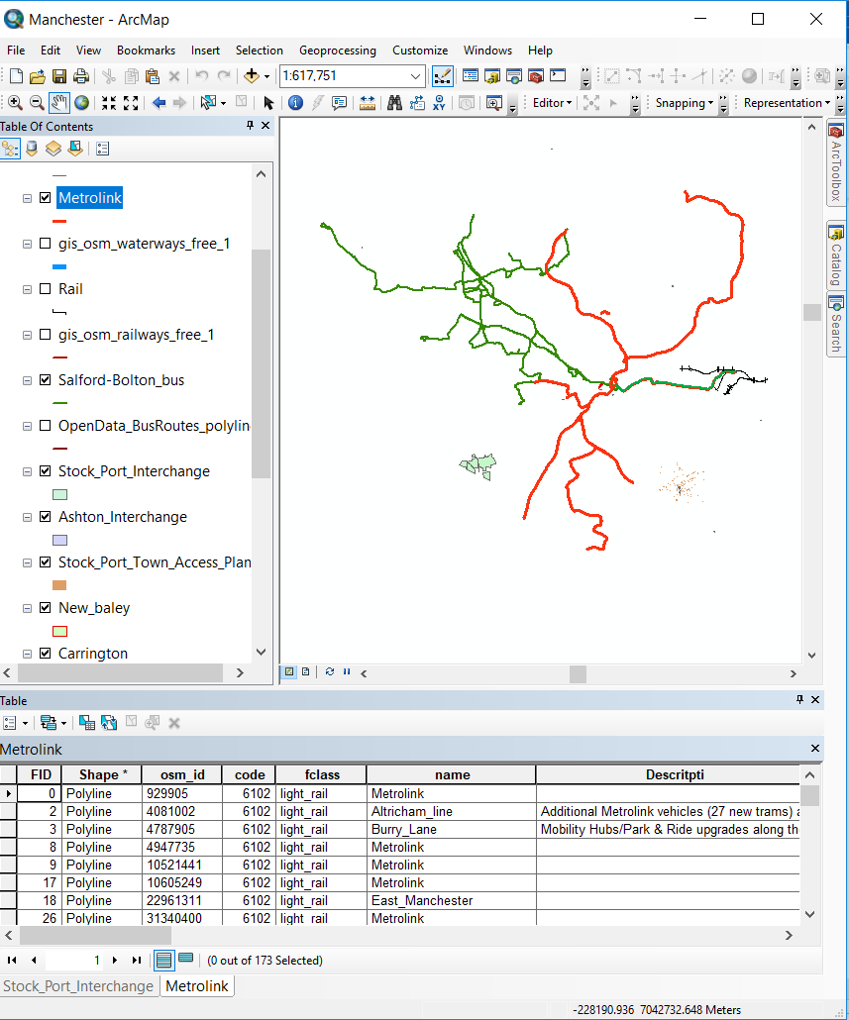

Figure 25 - ArcMap intermediate step to extract the shapefiles

The zipped shapefiles then have been uploaded into Mapbox and added as layers to the map visualization. Subsequently, a javascript file was creating adding all the codes required using the Mapbox GL libraries. Secondly for each layer (representing the interventions) a popup function was applied adapting the code from “Mapbox Examples” webpage (Mapbox, 2019a). Finally, adapting the code from the webpage “Fly to a location based on scroll position” (Mapbox, 2019b), a sliding bar was designed to show more information about each layer, the interactive aspect was guaranteed by using the “map.flyTo” function which zooms-in to each layer.

* 1. Results

The maps want to communicate the future projects related to the accessibility improvements, the web-page design is composed by two sliding columns and the central map showing the Greater Manchester area and the seven layers showing the above-mentioned interventions.

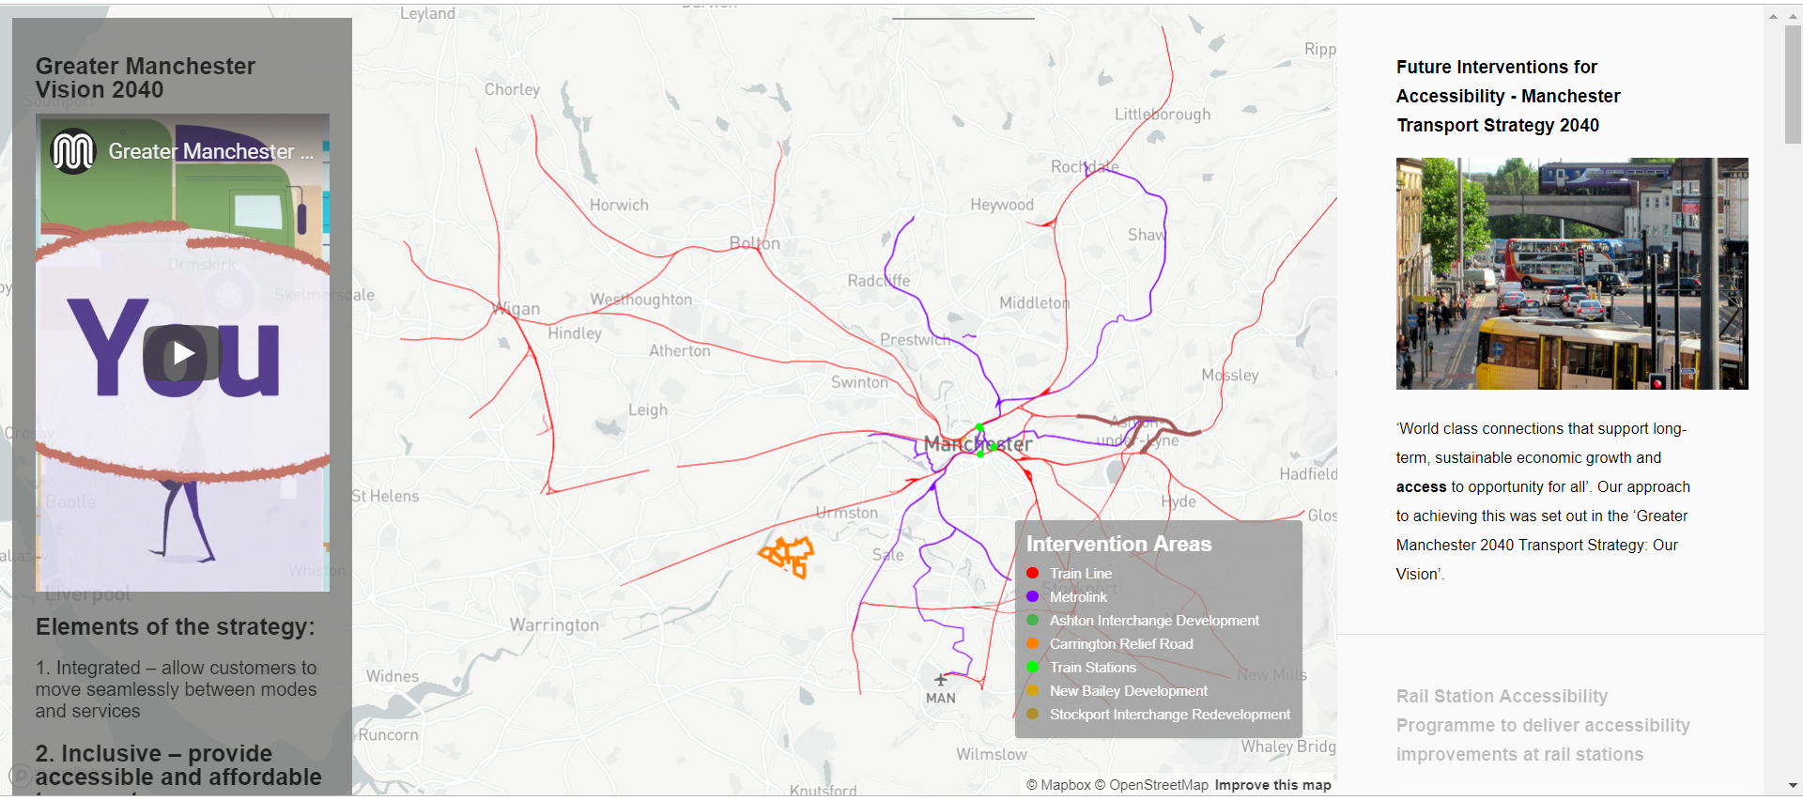

Figure 26 - Final visualization of the strategic interventions

The left column gives some general indications about the Manchester 2040 Strategy and emphasize the second pillar about inclusive-accessible idea. The right-hand-side column give more information about each intervention, the vertical sliding bar jumps to each of the intervention areas when scrolling down to the next section.

# Discussion & Conclusion

Our report contributes to represent a guide about accessibility state of art and plans in the context of a large developing country like the United Kingdom. With the total percentage of disabled people is growing in UK, in the following decades elderly people especially will require even more resources at city and national level

There is a regional difference in accessibility of the train station, accessible proportion is just a way of presenting data, and 100% accessible proportion does not mean that there are more accessible stations in this local authority area. At the local authority level, the distribution of the disabled population is very different between the proportion and the density. In terms of data, accessibility logically corresponds to the level of disability. Rail station's accessible facilities of Great Britain still need a lot of improvements, and some plans are already under implementation.

In the past the unemployment rate of the disabled people was quite bad across London. However, the visualization shows that there has been a consistent increase and progress. The high rate of economic inactivity, alongside a higher unemployment rate, explains why people with disabilities have a low employment rate. The number of people with disabilities who are in employment has been increasing since 2013. Since 2013, the disability employment gap consistently reducing. This has been because the employment rate for people with disabilities has been rising faster than the employment rate for people without disabilities.

The current wheelchair accessible businesses in London according to the Yelp data seems terrible and needs great improvement in the future. However, it may be because the Yelp data has some bias and cannot reflect the complete picture. Multiple data from other sources can be used to show more accurate picture in the future analysis.

Future interventions for accessibility improvement are not clearly indicating in the Manchester 2040 transport agenda. Transport strategies should integrate also accessibility plans at local and national level. Our invisible city (disabled people) require some future improvements in terms of infrastructure. The data visualized show that accessibility plans should be an integral part of any transport strategy.

# References

Bocarejo S., J.P., Oviedo H., D.R., 2012. Transport accessibility and social inequities: a tool for identification of mobility needs and evaluation of transport investments. *Journal of Transport Geography, Special Section on Theoretical Perspectives on Climate Change Mitigation in Transport*, [e-journal] 24, pp.142 - 154. <https://doi.org/10.1016/j.jtrangeo.2011.12.004>

CanvasJS, 2019. *jQuery Stacked Bar Charts & Graphs.* [online]. Available at: <<https://canvasjs.com/jquery-charts/stacked-bar-chart/>> [Accessed 14 May 2019].

Chartjs.org., 2019. *Chart.js documentation.* [online]. Available at: <<https://www.chartjs.org/docs/latest/>> [Accessed 27 May 2019].

Department for Transport, 2015. *Accessible rail transport*. [online]. Available at: <<https://www.gov.uk/government/publications/accessible-rail-transport/accessible-rail-transport>> [Accessed 22 April 2019].

Department for Transport, 2017. *Transport Statistics Great Britain 2017*. London: Department for Transport.

Diva-GIS, 2019. *Spatial Data Download - Country: United Kingdom - Subject: Railroads.* [online]. Available at: <<http://www.diva-gis.org/gdata>> [Accessed 22 April 2019].

Doogal, 2019. *UK stations.* [online]. Available at: <<https://www.doogal.co.uk/UkStations.php>> [Accessed 22 April 2019].

Euan's Guide, 2019. *Small Businesses and Accessibility.* [online]. Available at: <<https://www.disabledaccessday.com/news/small-businesses-accessibility/?tag=useful+articles>> [Accessed 26 May 2019].

Gersen, L., 2019. *noUiSlider - JavaScript Range Slider*. [online]. Available at: <<https://refreshless.com/nouislider/>> [Accessed 27 May 2019].

Great Britain Department for Transport, 2018. *Inclusive Transport Strategy.* [pdf] Great Britain Department for Transport. Available at: <<https://assets.publishing.service.gov.uk/government/uploads/system/uploads/attachment_data/file/728547/inclusive-transport-strategy.pdf>> [Accessed: 10 May 2019]

Hine, J., 2016. Mobility and transport disadvantage. In *Mobilities: New perspectives on transport and society* (pp. 39-58). Routledge.

London Datastore, 2019a. *Employment Rates by Disability.* [online] Available at: <<https://data.london.gov.uk/dataset/employment-rates-by-disability>> [Accessed May 2019].

London Datastore, 2019b. *Statistical GIS Boundary Files for London.* [online] Available at: <<https://data.london.gov.uk/dataset/statistical-gis-boundary-files-london>> [Accessed May 2019].

London Datastore, 2018. *Statistical GIS Boundary Files for London.* [online]. Available at: <<https://data.london.gov.uk/dataset/statistical-gis-boundary-files-london>> [Accessed 1 May 2019].

London-rhythms, 2018. *data processing.* [online]. Available at: <<https://github.com/london-rhythms/london-rhythms.github.io/tree/master/yelp/data%20processing>> [Accessed 1 May 2019].

Mapbox, 2019a. *Add a geocoder.* [online]. Available at: <<https://docs.mapbox.com/mapbox-gl-js/example/mapbox-gl-geocoder/>> [Accessed 14 May 2019].

Mapbox, 2019b. *Display a popup on click.* [online]. Available at: <<https://docs.mapbox.com/mapbox-gl-js/example/popup-on-click/>> [Accessed: 10 May 2019]

Mapbox, 2019c. *Filter features within map view.* [online]. Available at: <<https://docs.mapbox.com/mapbox-gl-js/example/filter-features-within-map-view/>> [Accessed 1 May 2019].

Mapbox, 2019d. *Fly to a location based on scroll position.* [online]. Available at: <<https://docs.mapbox.com/mapbox-gl-js/example/scroll-fly-to/>> [Accessed: 10 May 2019]

Mapbox, 2019e. *Show and hide layers.* [online]. Available at: <<https://docs.mapbox.com/mapbox-gl-js/example/toggle-layers/>> [Accessed 1 May 2019].

Mapbox, 2019f. *Swipe between maps.* [online]. Available at: <<https://docs.mapbox.com/mapbox-gl-js/example/mapbox-gl-compare/>> [Accessed 1 May 2019].

Network Rail, 2019. *Access for All – improving accessibility at railway stations nationwide.* [online]. Available at: <<https://www.networkrail.co.uk/communities/passengers/station-improvements/access-for-all/>> [Accessed 1 May 2019].

Office for National Statistics, 2017. *Local Authority Districts (December 2017) Super Generalized Clipped Boundaries in Great Britain.* [online]. Available at: <<https://geoportal.statistics.gov.uk/datasets/local-authority-districts-december-2017-super-generalised-clipped-boundaries-in-great-britain>> [Accessed 1 May 2019].

Office for National Statistics, 2012. *2011 Census: QS303EW Long-term health problem or disability, local authorities in England and Wales.* [online]. Available at: <<https://www.ons.gov.uk/peoplepopulationandcommunity/populationandmigration/populationestimates/datasets/2011censuskeystatisticsandquickstatisticsforwardsandoutputareasinenglandandwales>> [Accessed 1 May 2019].

Otto, M., 2019. *Forms.* [online]. Available at: <<https://getbootstrap.com/docs/4.3/components/forms/#checkboxes-and-radios>> [Accessed 27 May 2019].

Paulley, D., 2018. *Rail station accessibility data.* [online]. Available at: <<https://www.kingqueen.org.uk/rail-station-accessibility-data/>> [Accessed 1 May 2019].

Preston, J. and Rajé, F., 2007. Accessibility, mobility and transport-related social exclusion. *Journal of transport geography*, *15*(3), pp.151-160.

Scotland’s Census, 2013. *Long-term activity-limiting health problem or disability by council area, Scotland, 2001 and 2011.* [online]. Available at: <<https://www.scotlandscensus.gov.uk/bulletin-figures-and-tables>> [Accessed 1 May 2019].

Sigma Coding, 2018. *Using the Yelp API in Python (1).* [online]. Available at: <<https://www.youtube.com/watch?v=GJf7ccRIK4U>> [Accessed 1 May 2019].

Sze, N.N. and Christensen, K.M., 2017. Access to urban transportation system for individuals with disabilities. *IATSS research*, *41*(2), pp.66-73.

Transport for Greater Manchester, 2019. *The Greater Manchester Transport Strategy 2040.* [pdf] Transport for Greater Manchester. Available at: <<https://downloads.ctfassets.net/nv7y93idf4jq/7FiejTsJ68eaa8wQw8MiWw/bc4f3a45f6685148eba2acb618c2424f/03._GM_2040_TS_Full.pdf>> [Accessed: 10 may 2019]

StackExchange, 2018. [*Linking images to features in geojson layer popup using Leaflet?*](https://gis.stackexchange.com/questions/286245/linking-images-to-features-in-geojson-layer-popup-using-leaflet)***.*** [online]. Available at: <<https://gis.stackexchange.com/questions/286245/linking-images-to-features-in-geojson-layer-popup-using-leaflet>> [Accessed 14 May 2019].

Yelp, 2019a. */businesses/search.* [online]. Available at: <<https://www.yelp.com/developers/documentation/v3/business_search>> [Accessed 1 May 2019].

Yelp, 2019b. *Category List.* [online]. Available at: <<https://www.yelp.com/developers/documentation/v3/all_category_list>> [Accessed 1 May 2019].